STRUCTURAL BASIS OF MEDICAL PRACTICE
EXAMINATION 7

October 27, 2006
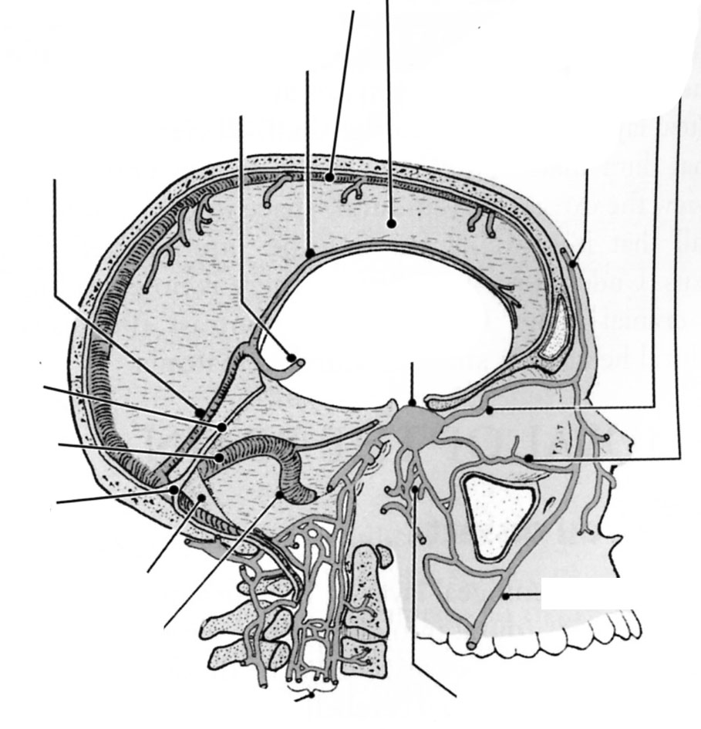
PART l. Answer in the space provided. (8 pts)

1. Identify the structures. (2 pts)
A

A. _Straight Sinus

B. _Inferior Sagittal Sinus

C. _Cavernous Sinus
C

D. _Pterygoid Venous Plexus

D

A
B
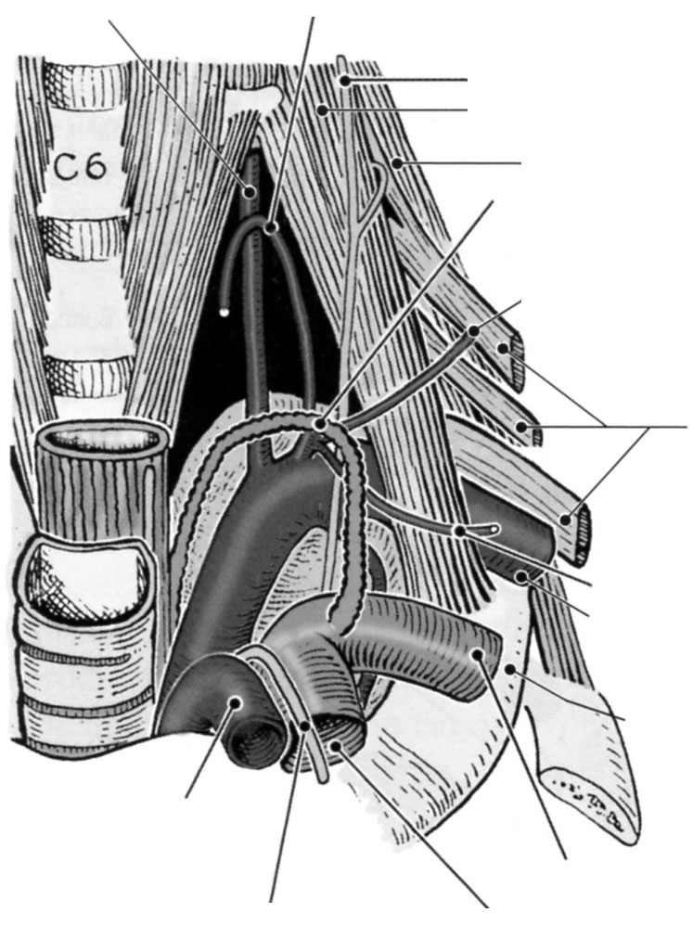
2. Identify the structures. (2 pts)

A. _Vertebral Artery
C

B. _Inferior Thyroid Artery
D

C. _Anterior Scalene Muscle

D. _Thoracic Duct

3. Identify the structure. (2 pts)
A
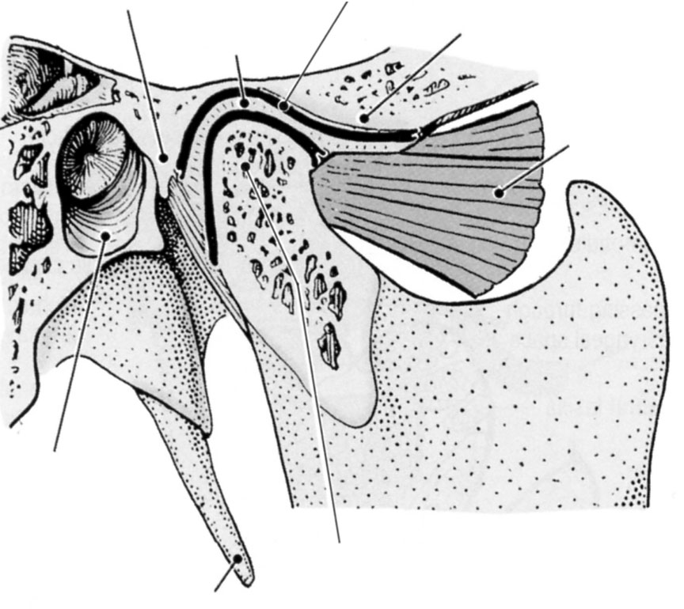
B
C
A. _Postglenoid tubercle

B. _Articular Disc
D

C. _Articular Tubercle

D. _Lateral Pterygoid M.

4. Identify the structure. (2pts)
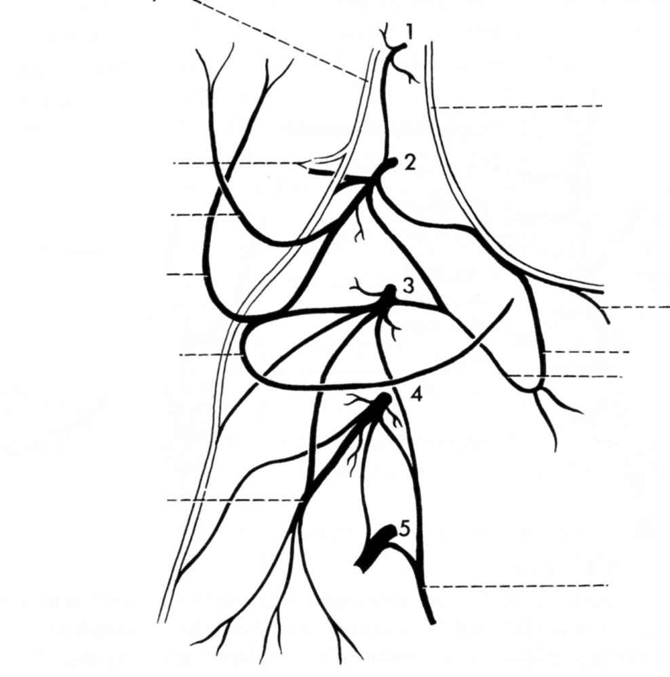
A. _Supraclavicular Nerves

B. _Hypoglossal Nerve
B

C. _Ansa Cervicalis

D. _Phrenic Nerve
D
A
C

Part II. Circle the correct answer. All, none, or some may apply. (26 pts)
1. With regard to the skull, face, and scalp:
- False. The pterion overlies the posterior branch of the middle meningeal artery making this arterial branch susceptible to injury.
- True. The buccinator muscle receives SVE innervation from the buccal branch of the facial nerve.
- False. The masseter muscle receives SVE inneration from the buccal nerve, a nerve derived from the mandibular division of the trigeminal nerve.
- False. The parotid duct pierces the masseter muscle to enter to oral cavity at the upper second molar.
- True. The pterygoid venous plexus communicates with the cavernous by way of an emissary vein.
- False. The vestibulorcochlear nerve exits the external auditory meatus.
- False. The mandibular branch of the trigeminal nerve exits the cranial cavity via the foramen rotundum.
- False. The infraorbital nerve enters the face deep to the zygomaticus major muscle.
2. With regard to the cranial nerves:
- False. The olfactory fascicles pass through the cribriform plate of the ethmoid bone to enter the ethmoidal air cells.
- False. A hypophyseal tumor is expected to disrupt central vision.
- True. A lesion of the inferior division of the oculomotor nerve at the annulus tendineus is expected to disrupt GSE and GVE components.
- False. A lesion of the internal carotid nerve is expected to disrupt postganglionic sympathetic GVE fibers and cause unilteral mydriasis.
- False. The chiasmatic groove is posterior to the hypophyseal fossa.
- False. The afferent limb of the corneal blink reflex is mediated by the SSA component of the optic nerve.
- False. Referred pain from laryngeal or pharyngeal cancers may occur at the external auditory meatus. This reflects the activities of the stapedial nerve and the tensor tympani muscle.
- False. The recurrent tympanic nerve, a branch of the chorda tympani, enters the tympanic cavity to provide SVE inneravtion to the tensor tympani muscle.

3. With regard to the anterior and posterior triangles of the neck:
- True. The ansa cervicalis is part of a somatic plexus whereas the ansa subclavia is part of an autonomic trunk.
- True. The phrenic nerve is deep to the prevertebral fascia and posterior to the suprascapular artery.
- True. The nerve to geniohyoid travels, in part, with the hypoglossal nerve.
- False. The nerve to mylohyoid passes along the superior surface of the mylohyoid muscle between it and hyoglossus muscle.
- True. The internal laryngeal nerve passes through the thyrohyoid membrane with the superior laryngeal artery.
- True. The hypoglossal nerve hosts non-native fibers derived from the cervical plexus.
- False. The glossopharyngeal nerve and the lingual nerve cross the medial surface of the hyoglossus.
- True. The cricothyroideus muscle, when fully contracted, raises the pitch of the voice.

4. With regard to the parotid region, temporal fossa, and the infratemporal fossa:
- True. The masseteric nerve passes through the mandibular notch.
- False. The buccal nerve passes the lateral aspect of the masseter muscle.
- False. A lesion of the chorda tympani within the infratemporal fossa is expected to decrease sensitivity of touch to the posterior 1/3 of the tongue as well as decrease lacrimation.
- False. The buccal nerve conveys SVE and GSA fibers to the buccinator muscle.
- False. The medial pterygoid muscle arises from the medial pterygoid plate whereas the lateral pterygoid muscle arises from the lateral pterygoid plate.
- False. The lingula of the mandible is a site of attachment for the stylomandibular ligament.
- True. A lesion of the lingual nerve at the foramen ovale is expected to disrupt touch (GSA) but not taste (SVA) to the anterior 2/3 of the tongue.
- True. Postganglionic fibers from the otic ganglion join onto; first the auriculotemporal nerve, and then the facial nerve.
- True. A lesion of the auriculotemporal nerve just medial to the neck of the mandible is expected to cause a salivatory deficit.
- False. The hamulus of the medial pterygoid plate is a site of attachment for the sphenomandibular ligament.
- True. The mouth may be stuck open if the condyle of the mandible slips forward of the articular tubercle.
- False. The hamulus is an inferior extension of the lateral pterygoid plate.
5. With regard to the larynx:
- True. The false vocal fold is superior to the true vocal fold.
- False. Lesions of both recurrent laryngeal nerves cause the vocal folds to be abducted.
- True. The external laryngeal nerve carries SVE fibers to cricothyroideus and possibly to cricopharyngeus.
- True. The recurrent laryngeal nerves lie in the tracheoesophageal groove and pass the posterior surface of the thyroid gland.
- True. The muscular process of the arytenoid cartilage is anterior and lateral to the belly of the posterior cricoarytnoideus muscle.
- False. The false vocal fold is at the superior free edge of the conus elasticus.
- True. The pirifrom recesses extend inferior as far as the upper esophageal sphincter.
- False. The cough reflex is mediated by GVA fibers derived from the glossopharyngeal nerve.
6. With regard to the temporal bone and ear:
- True. A lesion of the facial nerve distal to the stapedial branch and proximal to the chorda tympani branch will not cause hyperacusis (SVE) but will disrupt taste (SVA) and salivation (GVE).
- True. A lesion of the facial nerve as it enters the parotid gland is expected to reduce salivation.
- False. The stapes attaches to the round window.
- True. For the most part, the helix borders the outer convexity of the antihelix.
- True. A lesion of the greater superficial petrosal nerve at the lacerate foramen will cause an ipsilateral dry eye but will not affect sensitivty to loud noises.
- True. The mastoid air cells, aditus, and auditory tube form a continuous airway that communicates with the nasopharynx.
- True. The tragus is anterior to the antitragus.
- True. A lesion of the facial nerve at the stylomastiod foramen will cause paralysis of unilateral facial musculature but is not expect to affect salivation.
Part III. Indicate your understanding (importance, function, relationships, vasculature, nerves, boundaries, and contents) of the following. Answer in the space provided. (30 pts)

- Parotid region. (6 pts)

- Drainage of the paranasal sinuses. (6 pts)

- Arterial supply to the cranial cavity. (6 pts)

- Muscular process of the arytenoid cartilage. (6 pts)

- Transverse process of C6 (6 pts)
Part IV. Answer in the space provided (including the back of the page or the additional pages for each question). (36 pts)

1. Dr. Bollard explained that patients with trigeminal neuralgia need to decide for themselves what is worse – the pain of neuralgia or the numbness that results from nerve block. A treatment for trigeminal neuralgia is to inject nerve blocking agents into the pterygopalatine fossa. Discuss the Pterygopalatine Fossa. Include contents, relationships, foramina, nerve distributions, and the expected consequences of blocking each nerve and functional component within the pterygopalatine fossa. (12 pts).

2. Drs. Quillen and Wilkinson explained that enlargement of the orbital contents causes exophthalmos. Discuss the anatomy of the orbit. Include contents, relationships, fascial specializations, vascularization, innervation, lymphatic drainage, muscles and movements, and nerve injury. What grave condition is indicated by pulsatile exophthalmos? (12 pts)

3. Drs. Fornadley and Fedok explained how infections that erode the pharyngeal walls can become widely dispersed. Discuss the pharynx. Include fascial barriers, contents, relationships, nerve distributions, and nerve injury. Discuss the spread of infection from the pharynx into the spaces defined by the cervical fascias. (12 pts)

